Tertiary Infotech Academy Pte Ltd
UEN: 201200696W

LESSON PLAN
For

Microsoft Azure Security Engineer Associate (AZ-500)
TGS Ref No: TGS-2023039344
Conducted by
Tertiary Infotech Academy Pte Ltd
UEN: 201200696W
Version 4

Document Version Control Record
Version Number | Effective Date of Release | Summary of Included Changes | Author
4 | 8 July 2026 | Aligned assessment flow to WA then PP and regenerated courseware/lab-aligned materials. | Tertiary Infotech Academy Pte Ltd

Table of Contents
Right-click and choose 'Update Field', or press F9, to build the table of contents.

Course Details
Course Title | Microsoft Azure Security Engineer Associate (AZ-500)
TGS Ref No. | TGS-2023039344
Duration | 2 Days (16 training hours)
Training Hours | 9:00 AM - 6:00 PM, including lunch and short breaks
Delivery Mode | Instructor-led classroom training with Azure hands-on labs
Learning Platform | Azure Portal, Microsoft Entra admin center, Defender for Cloud, Microsoft Sentinel and LMS
Assessment | Written Assessment (1 hr) and Practical Performance (1 hr) on Day 2 from 4:00 PM to 6:00 PM
Learner Guide | LG-Microsoft Azure Security Engineer Associate (AZ-500).docx
Slide Deck | Microsoft Azure Security Engineer Associate (AZ-500)-v4.pptx
Lab Source | labs/ folder, 8 markdown labs
Primary Resource Group | rg-az500-<initials>
Region Used | Southeast Asia

Note: The 'Slides' column in each schedule table references the exact slide numbers in the Learner Guide Slides deck for that activity.

Course Overview
This 2-day hands-on course prepares learners to secure Azure identity, networking, compute, data and security operations services. Learners configure controls, validate outcomes, record evidence and document licensing or permission blockers where a feature is unavailable.

Learning Outcomes
By the end of this course, participants will be able to:
- Configure least-privilege access with Azure RBAC, custom roles, PIM and Conditional Access.
- Protect Azure network traffic with segmentation, NSG/ASG rules, Firewall, WAF and Private Endpoints.
- Secure compute, storage, SQL and Key Vault using Bastion, JIT, encryption and exposure controls.
- Manage security posture and response using Azure Policy, Defender for Cloud and Microsoft Sentinel.

Delivery Diagram - Course Flow
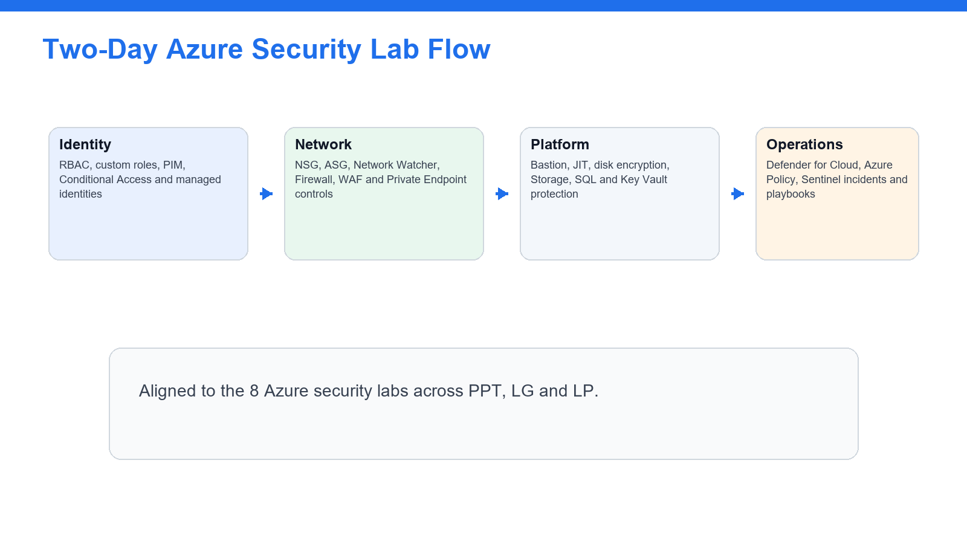
Trainer view of the two-day flow and the order in which learners encounter the labs.

Delivery Diagram - Governance Emphasis
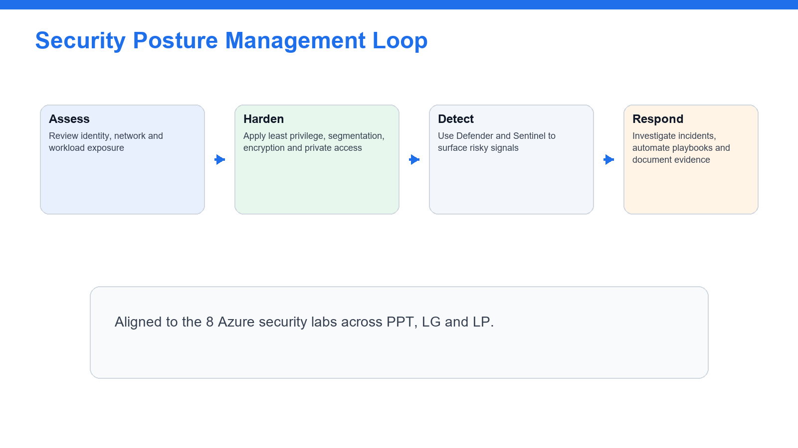
Day 2 emphasises workload/data protection, posture management and security operations.

Delivery Diagram - AZ-500 Lab Domain Matrix
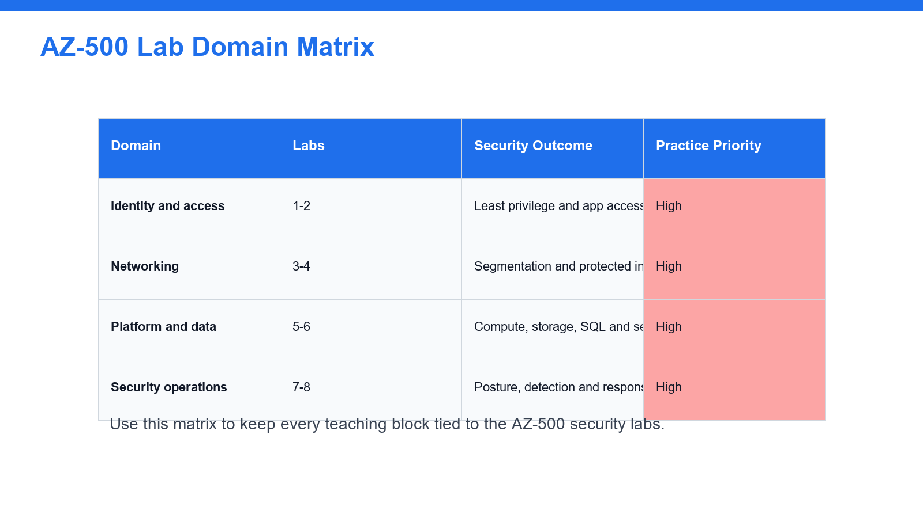
The schedule keeps every activity tied to the eight AZ-500 labs.

Day 1
Topic 1: Identity, access and network protection
Morning Session - 9:00 AM - 1:00 PM
Time | Activity / Topic | Slides | Duration
9:00-9:40 | Welcome, trainer introduction, ground rules, attendance, assessment briefing and lab access | 1-16 | 40 min
9:40-10:40 | Lab 1: Configure RBAC, custom roles and privileged access review | 24-26 | 60 min
10:40-10:50 | Tea Break | - | 10 min
10:50-12:00 | Lab 2: Secure app access with Conditional Access and managed identities | 27-29 | 70 min
12:00-1:00 | Lab review: identity evidence, missing permissions and least privilege decisions | 24-29 | 60 min

Lunch - 1:00 PM - 1:45 PM
Afternoon Session - 1:45 PM - 6:00 PM
Time | Activity / Topic | Slides | Duration
1:45-3:15 | Lab 3: Secure virtual networks with NSGs, ASGs, peering and Network Watcher | 30-32 | 90 min
3:15-3:25 | Tea Break | - | 10 min
3:25-5:10 | Lab 4: Protect public and private access with Azure Firewall, WAF and Private Endpoints | 33-35 | 105 min
5:10-6:00 | Day 1 recap: identity/network threat model and lab evidence review | 30-35 | 50 min

Day 2
Topic 2: Platform protection, data protection and security operations
Morning Session - 9:00 AM - 1:00 PM
Time | Activity / Topic | Slides | Duration
9:00-10:25 | Lab 5: Secure virtual machines, Bastion, JIT access and disk encryption | 36-38 | 85 min
10:25-10:35 | Tea Break | - | 10 min
10:35-12:00 | Lab 6: Protect Storage, SQL Database and Key Vault secrets | 39-41 | 85 min
12:00-1:00 | Lab review: compute/data evidence, encryption and public exposure decisions | 36-41 | 60 min

Lunch - 1:00 PM - 1:45 PM
Afternoon Session - 1:45 PM - 6:00 PM
Time | Activity / Topic | Slides | Duration
1:45-2:45 | Lab 7: Manage security posture with Azure Policy and Defender for Cloud | 42-44 | 60 min
2:45-3:45 | Lab 8: Monitor, investigate and automate with Microsoft Sentinel | 45-47 | 60 min
3:45-4:00 | Assessment readiness briefing and submission checks | Assessment slides | 15 min
4:00-5:00 | Written Assessment (WA) | - | 60 min
5:00-6:00 | Practical Performance (PP), LMS submission and Assessment Summary Record | - | 60 min

Topic-by-topic Breakdown with Slide Numbers

Lab 1 - Configure RBAC, Custom Roles, and Privileged Access Review - Slides 24-26
Domain: Domain 1 - Secure identity and access. Source lab file: labs/lab-01-identity-rbac-pim.md.
In this lab you will configure Azure role-based access control, create a scoped custom role, and review privileged access patterns with Microsoft Entra Privileged Identity Management.
- Step 1 - Create the training resource group
- Step 2 - Review inherited access
- Step 3 - Assign a built-in role
- Step 4 - Create a custom role definition
- Step 5 - Review privileged identity management

Lab 2 - Secure App Access with Conditional Access and Managed Identities - Slides 27-29
Domain: Domain 1 - Secure identity and access. Source lab file: labs/lab-02-conditional-access-managed-identities.md.
In this lab you will review Conditional Access, app registrations, service principals, OAuth consent, and managed identities. These controls are central to secure identity and application access in Azure.
- Step 1 - Review Conditional Access policies
- Step 2 - Review sign-in impact
- Step 3 - Create an app registration
- Step 4 - Review API permissions and consent
- Step 5 - Enable a managed identity

Lab 3 - Secure Virtual Networks with NSGs, ASGs, Peering, and Network Watcher - Slides 30-32
Domain: Domain 2 - Secure networking. Source lab file: labs/lab-03-network-security-nsg-asg.md.
In this lab you will create a segmented virtual network, apply Network Security Groups, use Application Security Groups, and validate traffic using Network Watcher.
- Step 1 - Create a virtual network
- Step 2 - Create application security groups
- Step 3 - Create network security groups
- Step 4 - Associate NSGs to subnets
- Step 5 - Use Network Watcher IP flow verify

Lab 4 - Protect Public and Private Access with Azure Firewall, WAF, and Private Endpoints - Slides 33-35
Domain: Domain 2 - Secure networking. Source lab file: labs/lab-04-firewall-waf-private-endpoints.md.
In this lab you will design public and private access protections using Azure Firewall, Web Application Firewall concepts, and Private Endpoints. Some resources can be reviewed instead of deployed if your training subscription has quota or cost limits.
- Step 1 - Plan firewall placement
- Step 2 - Review firewall policy rules
- Step 3 - Review WAF protection
- Step 4 - Create a storage account private endpoint
- Step 5 - Review public access settings

Lab 5 - Secure Virtual Machines, Bastion, JIT Access, and Disk Encryption - Slides 36-38
Domain: Domain 3 - Secure compute, storage, and databases. Source lab file: labs/lab-05-compute-security-vm-bastion-jit.md.
In this lab you will secure administrative access to virtual machines and review compute hardening options such as Bastion, Just-in-Time access, and disk encryption.
- Step 1 - Create a test virtual machine
- Step 2 - Deploy or review Azure Bastion
- Step 3 - Remove public management exposure
- Step 4 - Configure Just-in-Time VM access
- Step 5 - Review disk encryption options

Lab 6 - Protect Storage, SQL Database, and Key Vault Secrets - Slides 39-41
Domain: Domain 3 - Secure compute, storage, and databases. Source lab file: labs/lab-06-storage-sql-key-vault.md.
In this lab you will configure security controls for Azure Storage, Azure SQL Database, and Azure Key Vault.
- Step 1 - Harden storage account access
- Step 2 - Review storage keys and shared access
- Step 3 - Create a Key Vault
- Step 4 - Add and protect a secret
- Step 5 - Create or review Azure SQL Database security

Lab 7 - Manage Security Posture with Azure Policy and Defender for Cloud - Slides 42-44
Domain: Domain 4 - Manage security operations. Source lab file: labs/lab-07-defender-policy-secure-score.md.
In this lab you will use Azure Policy and Microsoft Defender for Cloud to assess compliance, secure score, and recommended remediation actions.
- Step 1 - Assign an Azure Policy
- Step 2 - Review compliance
- Step 3 - Open Defender for Cloud
- Step 4 - Review regulatory compliance
- Step 5 - Review Defender plans

Lab 8 - Monitor, Investigate, and Automate with Microsoft Sentinel - Slides 45-47
Domain: Domain 4 - Manage security operations. Source lab file: labs/lab-08-sentinel-monitor-investigate-automate.md.
In this lab you will configure a Microsoft Sentinel workspace, connect data, run KQL queries, create an analytics rule, and review automation options.
- Step 1 - Create a Log Analytics workspace
- Step 2 - Enable Microsoft Sentinel
- Step 3 - Connect Azure activity data
- Step 4 - Run basic KQL queries
- Step 5 - Create an analytics rule
- Step 6 - Review automation

Tools, Accounts & Resources
Resource | Purpose | Notes
Training subscription or sandbox | Create and manage lab resources | Use a subscription with permissions and required licensing.
Azure Portal | Portal-based labs | https://portal.azure.com
Microsoft Entra admin center | Identity and Conditional Access labs | https://entra.microsoft.com
Defender for Cloud | Posture and secure score labs | Use Azure Portal or Defender portal as instructed.
Microsoft Sentinel | SIEM, incidents and automation labs | Use Log Analytics workspace and Sentinel permissions.
LMS/TMS | Courseware, TRAQOM, attendance and assessment | https://lms-tms.tertiaryinfotech.com/

Assessment
- Learners complete all eight hands-on labs before the assessment block where possible.
- Assessment flow: TRAQOM attendance, assessment attendance, written assessment, LMS submission and assessment record signing.
- Learners should revise weak areas using the AZ-500 lab domain matrix and lab evidence notes.

